User Manual



User Manual 1

1. Introduction 2

2. Installation 2

3. Adding Experiment 3

4. Updating Experiment 5

5. Removing Experiment 6

6. Running Experiment 6

7. Log Files 7

8. Uninstall 7

## Introduction

Smart fMRI is a user-friendly Graphical User Interface for E-prime2. It provides user-friendly UI during running E-Prime2 paradigm (*.ebs2 file) for an fMRI experiment.

The main window:

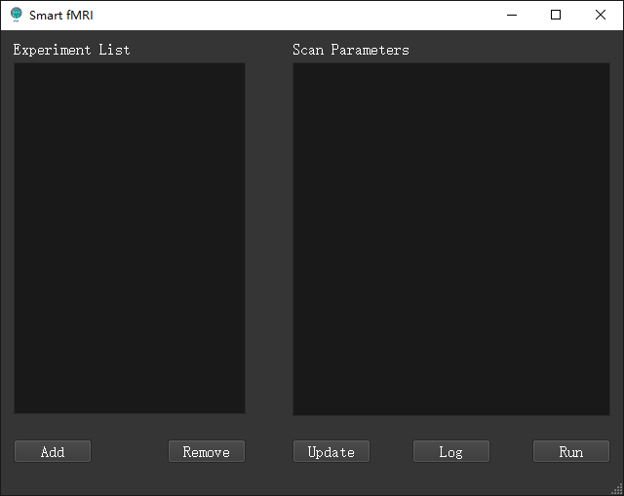

It provides following benefits:

1. Experiments can be easily managed. The same experiments can have multiple copy.
2. Parameters of each experiment are editable.
3. Log files are automatically saved by time sequence with timestamp.
4. Background monitoring E-Prime2’s output. It is possible to monitor the E-Prime2’s output in another screen.

## Installation

* 1. Before using this software, E-Prime 2 should be well installed.
  2. Follow the Smart fMRI setup wizard to install your Smart fMRI program. The program will be installed in installation path you selected and a shortcut will be placed in the desktop.
  3. Double click the shortcut on your desktop, the following window may pop up.

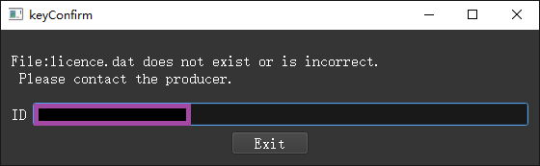

This is caused by lack of correct licence.dat, which means users need to use ID to apply a licence.dat to place in their installation path. After that, the whole function should work.

## Adding Experiment

* 1. First of all, it need to add an E-Prime2 paradigm (*.ebs2) to its storage directory as an experiment. The paradigm it supports to add should have following format:

1. All resource files need to use should be in the same folder where the paradigm file (*.ebs2) is.

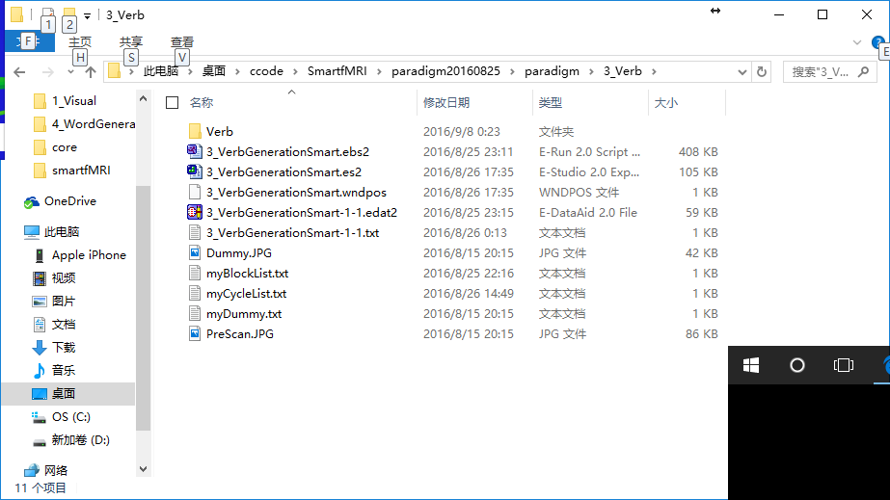

1. The folder MUST contain editable configuration files (‘myBlockList.txt’ & ‘myCycleList.txt’ & ‘myDummy.txt’) whose filenames are restricted.
2. The configuration files MUST have following format:

The first row is the title which MUST and ONLY contain the followings, the second row is parameters. Each column is separated by a ‘Tab’.

‘myBlockList.txt’:

ID Weight Procedure Nested PracticeMode

1 15 TaskBlockProc No

2 15 RestBlockProc No

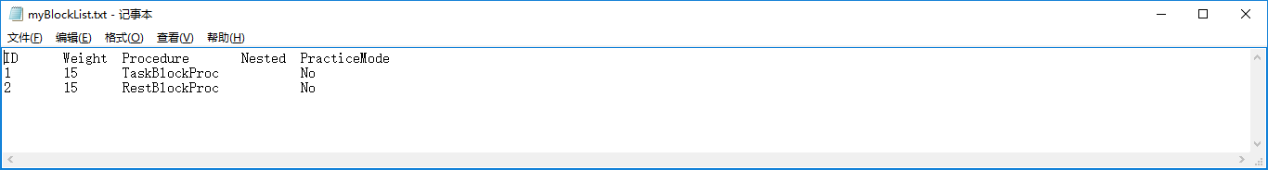

‘myCycleList.txt’:

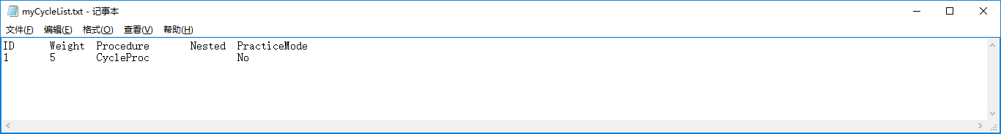

ID Weight Procedure Nested PracticeMode

1 5 CycleProc No

“myDummy.txt”:

ID Weight Duration Procedure Nested

1 1 6000 DummyProc

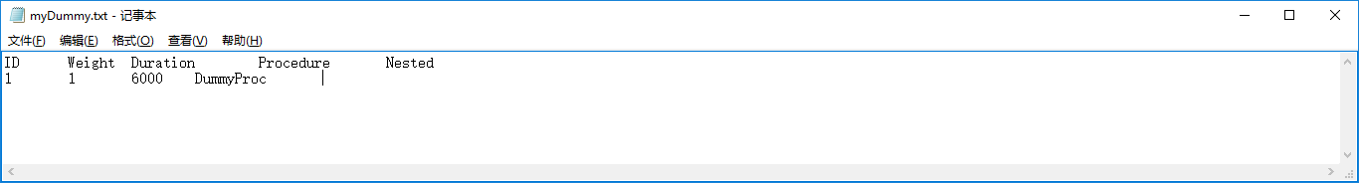

The upper ‘*.txt’ files should be set in the E-Studio as follows in the design of a paradigm.

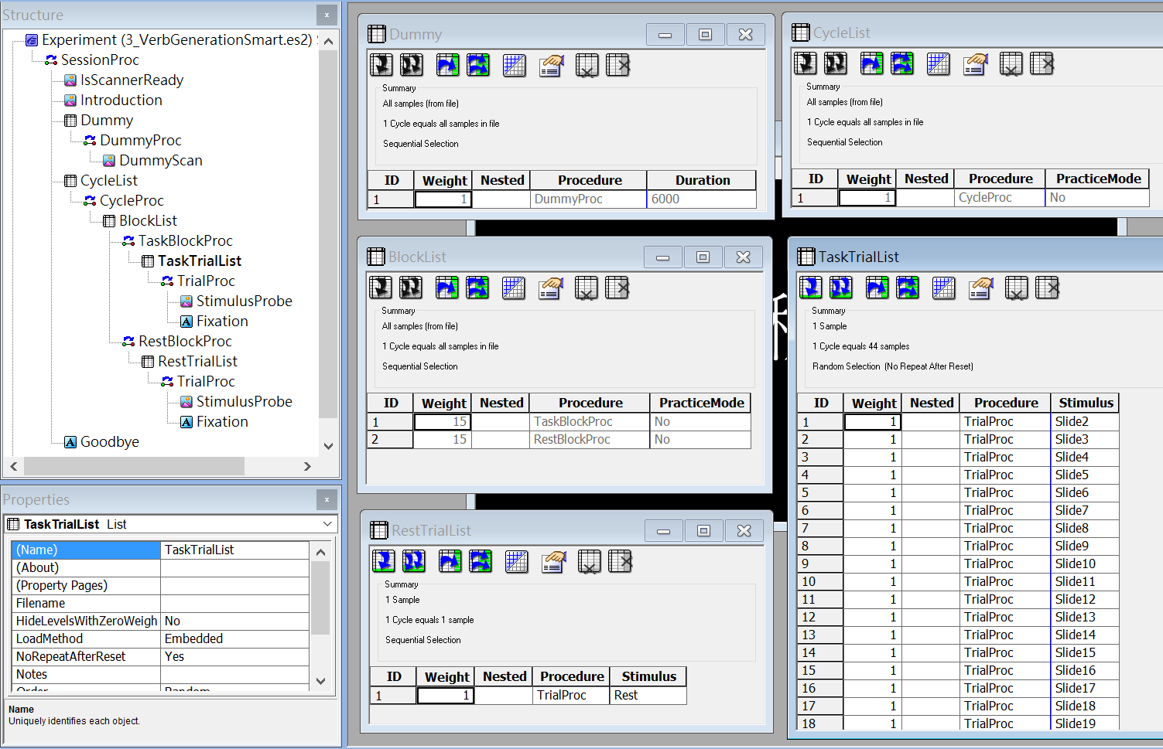

‘myTrialListParameters.txt’:

ID Weight Procedure Nested Stimulus CorrectAnswer StimDuration FixationDuration

1 4 TrialProc RedCar.bmp 1 1000 1000

‘myTrialListParameters.txt’ should be set in the E-Studio as follows in the design of a paradigm.

* 1. For adding an experiment, click the ‘Add’ button of the main window, ‘Smart fMRI’. Select the paradigm file (*.ebs2) in the bowser and click ‘Open’.



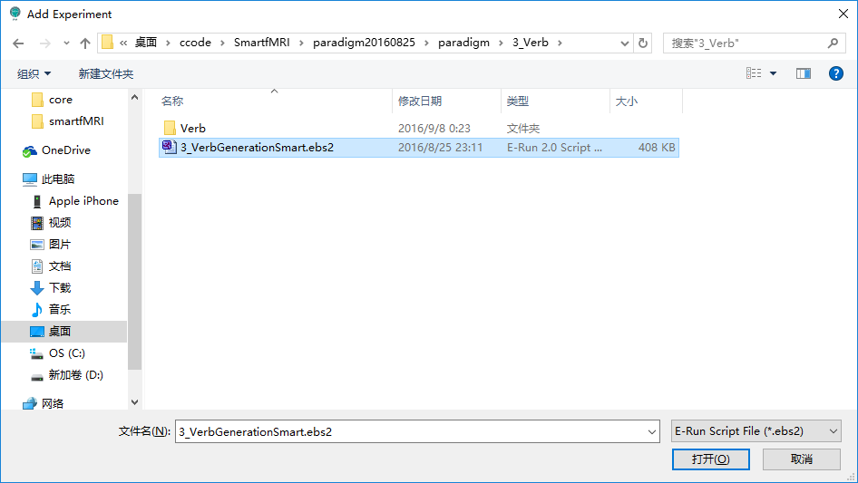

* 1. Before a dialog, ‘Experiment Manager’ pop up, the type of experiment is needed to select. Scan parameters of Clinical experiment can be updated, while research experiment cannot. On the left side of ‘Experiment Manager’, ‘Experiment Name’ edit text is the folder name and experiment name. ‘Paradigm Name’ is the file name of ‘*.ebs2’ file. On the right is a table of scan parameters. Click ‘Confirm’ button.

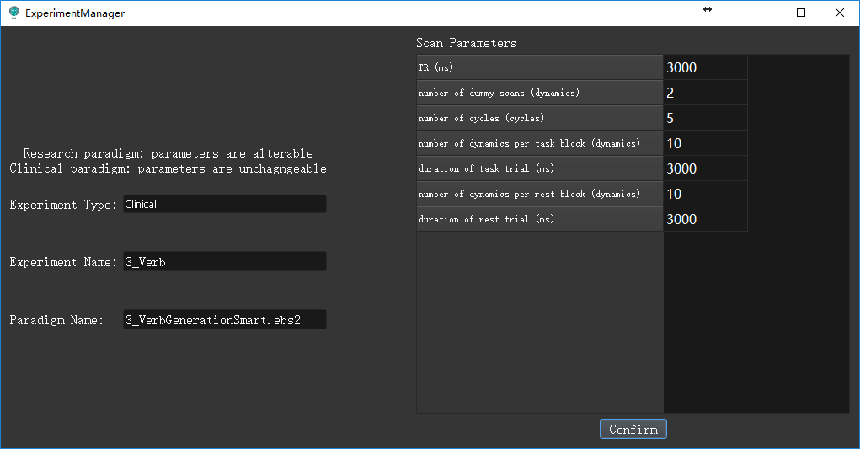

* 1. A new experiment will be added to the list of the main window. The right list is all the added experiments. The right table is the scan parameters of the selected experiments.

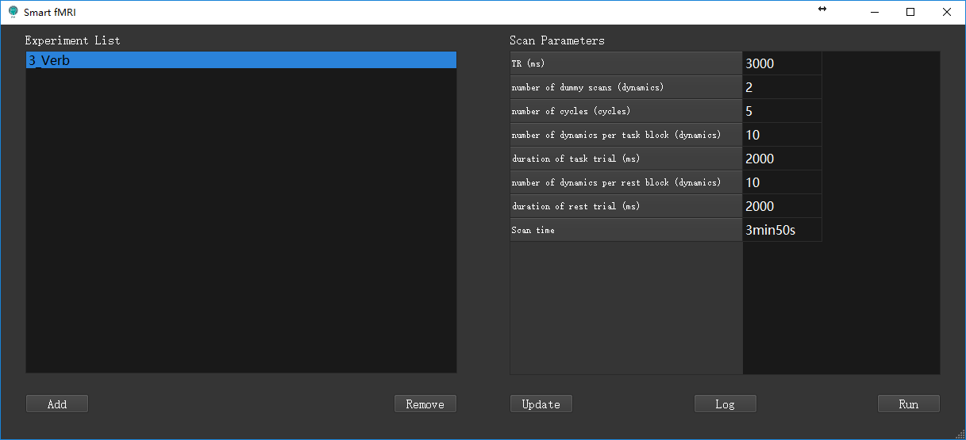

* 1. A new directory is also created in $Smart fMRI/paradigm/$Experiment Name. (While it is not suggested to alter directories)

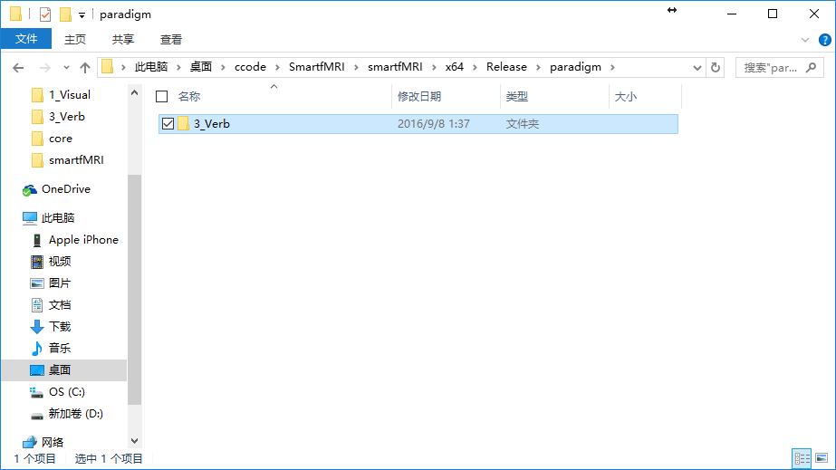

## Updating Experiment

* 1. Select an experiment in ‘Experiment List’ and click ‘Update’ button can alter the scan parameters and Experiment. It is the same as instruction 3.3, while no experiment will be added.

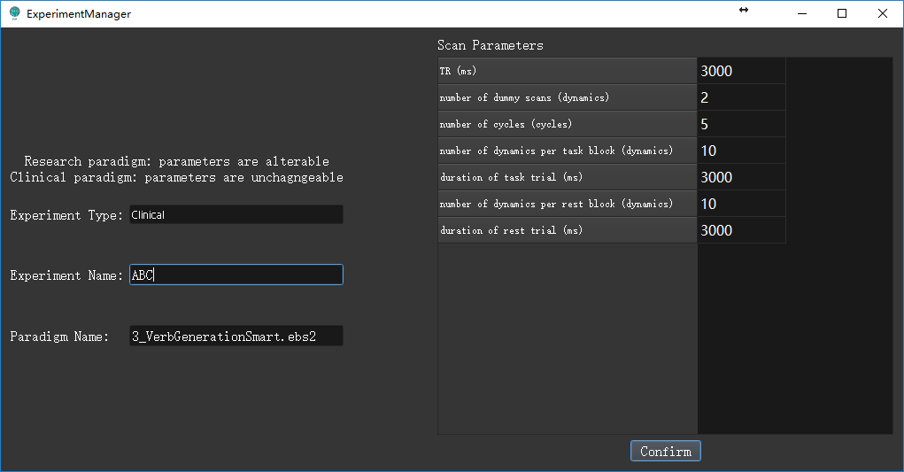

## Removing Experiment

* 1. Select an experiment, click ‘Remove’. The selected experiment will be remove from the list and all its related directories, files, data, logs are also removed. It cannot be found in the recycle bin and INVERTIABLE.

## Running Experiment

* 1. Select an experiment, click ‘Run’. The selected experiment will run immediately.
  2. The Experiment status dialog will display the patient’s movement. Experiment date, begin time and end time. B: block, T: trail, K: keyboard response (‘ ‘ means no response), A: accuracy, RT: response time (‘0’ means no response).

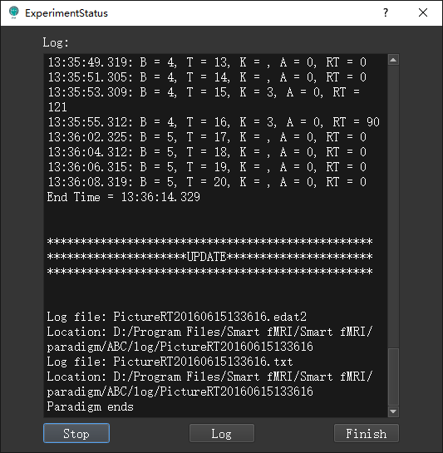

* 1. After finishing, it will tell the location of the files.
  2. If abortion during the experiment, the log files will not be saved.
  3. Click ‘Stop’ button and ‘Finish’ button or click ‘Finish’ button directly.

## Log Files

* 1. In 6.2., click the ‘log’ button in the bottom of ‘Experiment status’ dialog, it will open the log folder of the log files.
  2. Select an experiment in 4.1 and click ‘Log’ button, which is the same as 6.2.

## Uninstall

* 1. Double click ‘uninstall.bat’ in installation path and click ‘yes’. The program will be uninstalled right away.

